**Interface design - Improve the Road Safety in Breda**

Ron L. Tabuchov

Mohamed K. A. M. Elshami

Daria Vlăduţu

Peter Husen

Data Science and Artificial Intelligence, Breda University of Applied Science

Academy/Department

Saturday 01 January 2022

Index

**Contents**

Index 2

1 Background 3

2 Goal 3

3 Method 3

4 Data collection 3

5 Data Analysis 4

6 Results 4

7 Re-adjustments 5

8 Interpretation 5

9 Conclusion 6

# Background

This document outlines the steps involved in conducting an A/B test to compare two versions of an application. The purpose is to evaluate which version performs better based on user feedback. This guide serves to ensure clarity and effective collaboration among stakeholders.

# Goal

The goal of this A/B test is to determine whether Version A or Version B of the application provides a better user experience. This will be measured using specific metrics such as usability, intuitiveness, usefulness, enjoyment, and clarity of the application's buttons.

# Method

To conduct this A/B test, we followed these steps:

1. **Formulate Hypotheses**: Define what you are testing and what you expect to find.
2. **Design the Experiment**: Randomly assign users to either Version A or Version B.
3. **Collect Data**: Gather user feedback through surveys or usage data.
4. **Analyze Data**: Use statistical methods to compare the results.
5. **Interpret Results**: Draw conclusions from the data analysis.

# Data collection

Participants were randomly assigned to either [Version A](https://www.figma.com/proto/jzar4rAjbEHxkHtHvmMR77/Version-A---RAAI-(Road-Assistance-with-Artificial-Intelligence)?node-id=2005-128&t=mjkzBEDkc3SlxefK-1&scaling=scale-down&page-id=0%3A1&starting-point-node-id=2005%3A128) or [Version B](https://www.figma.com/proto/e6XppffUkrFvZaY0NPiN9Q/Version-B---RAAI-(Road-Assistance-with-Artificial-Intelligence)?node-id=2005-128&t=TbZH9dUo85HIxKTd-1&scaling=scale-down&page-id=0%3A1&starting-point-node-id=2005%3A128) of the application. They were asked to complete a survey assessing their experience on the following aspects:

* Understanding the purpose of the app
* Intuitiveness of use
* Usefulness of the app
* Enjoyment of using the app
* Clarity of the app's buttons

The survey used a Likert scale from 1 (completely disagree) to 7 (completely agree).

# Data Analysis

We used the following steps for data analysis:

1. **Combine Data**: Integrate data from both versions into a single dataset.
2. **Calculate Descriptive Statistics**: Compute means and standard deviations for each question for both versions.
3. **Perform T-tests**: Conduct t-tests to compare the means of the two groups for each question.

[Link to AB-test analysis](https://github.com/BredaUniversityADSAI/2023-24d-fai1-adsai-teamwork-t18/blob/main/User%20testing/AB-test%20Analysis.ipynb)

# Results

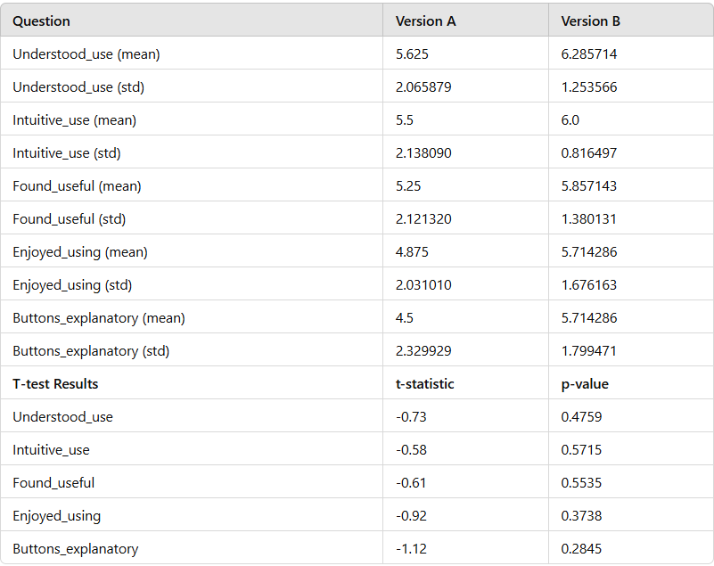

# Re-adjustments

Based on the findings from the A/B test, several adjustments were made to improve the app's user experience.

#### Addition of RAAI Button

* **Feature**: A Road Assistance using Artificial Intelligence (RAAI) button was added in the driving mode.
* **Functionality**: Users can turn the RAAI feature on or off by pressing this button.
* **Purpose**: The RAAI feature provides enhanced road assistance, aiming to improve safety and user convenience.
* **User Feedback**: Preliminary feedback from users who tested the RAAI feature has been positive, indicating that it adds significant value to the driving mode experience.

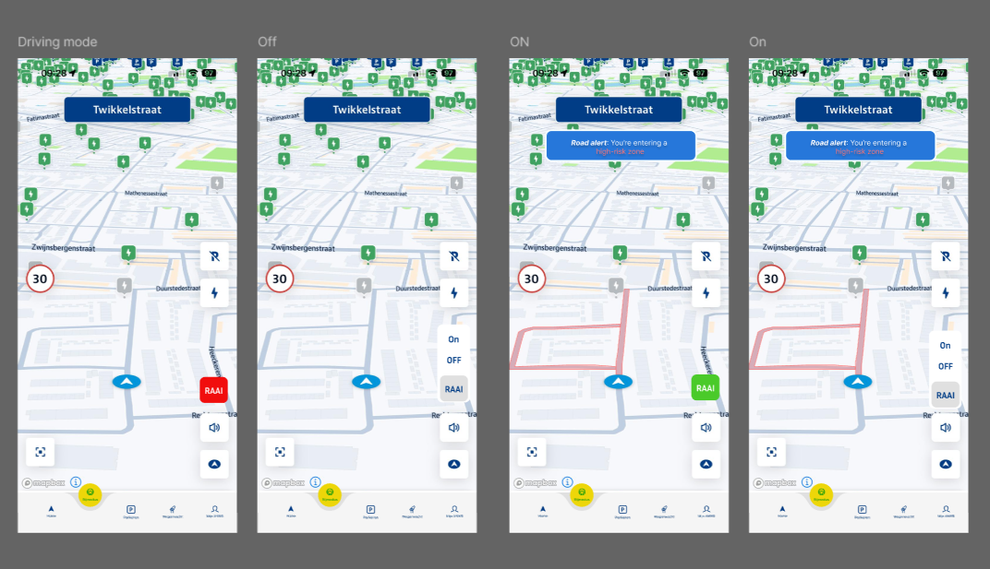

# Interpretation

The results indicate that Version B tends to have higher mean scores across all questions compared to Version A, despite the p-values indicating that the differences are not statistically significant at a conventional level. However, the consistent higher scores for Version B suggest a preference for Version B among users.

# Conclusion

Based on the analysis of the data, Version B is preferred over Version A due to higher average ratings in all measured aspects. While the statistical significance is not strong, the trend in the data indicates that Version B provides a better user experience overall.